



Dog shelter

By team ARTEMISSION

Table of Contents

1. Our team 2

2. Aim 3

3. Used technologies 3

4. Block diagram 3

5. Future ideas 3



# Our team

Afra Yusrefova

AFYusrefova18@codingburgas.bg

Emily Kehayova 10A

EDKehayova18@codingburgas.bg

# Aim

We wanted to create a system that will make adopting animals from shelters easier for the people working there and for the people who wish to adopt a dog.

# Used technologies



Photoshop

MSSQL

Visual studio

# Block diagram

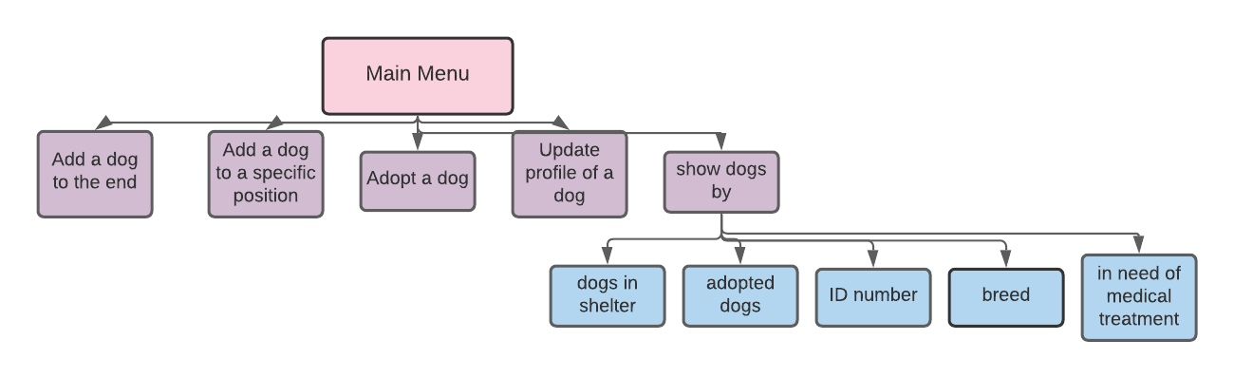

# Future ideas

* To connect the solution with the database
* To make the program more user friendly